PRACTICAL-2

OBJECTIVE-CREATE AMAZON ELASTIC BLOCK STORE (EBS) VOLUMES IN AWS AND ATTACH IT TO THE INSTANCE.
Steps to Create an EBS volumes in AWS
- Login to AWS Console.
- Sign in with your AWS account credentials.
- Search for EC2: In the search bar at the top of the AWS Management Console, type “EC2” .
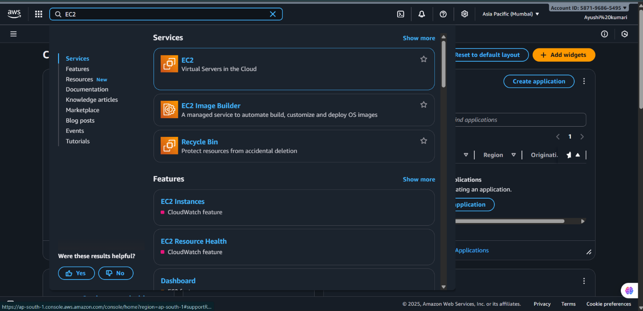
- Select EC2 Service: From the search results under Services, click on EC2 – Virtual Servers in the Cloud. This will open the EC2 Dashboard, where you can manage instances, volumes, and other resources.

- Create an EBS Volume In the left sidebar, under "Elastic Block Store," select "Volumes."
- Click "Create volume."
- Specify settings: Choose volume type (e.g., General Purpose SSD gp3). Set size (e.g., 100 GiB), IOPS, throughput, and choose the availability zone.
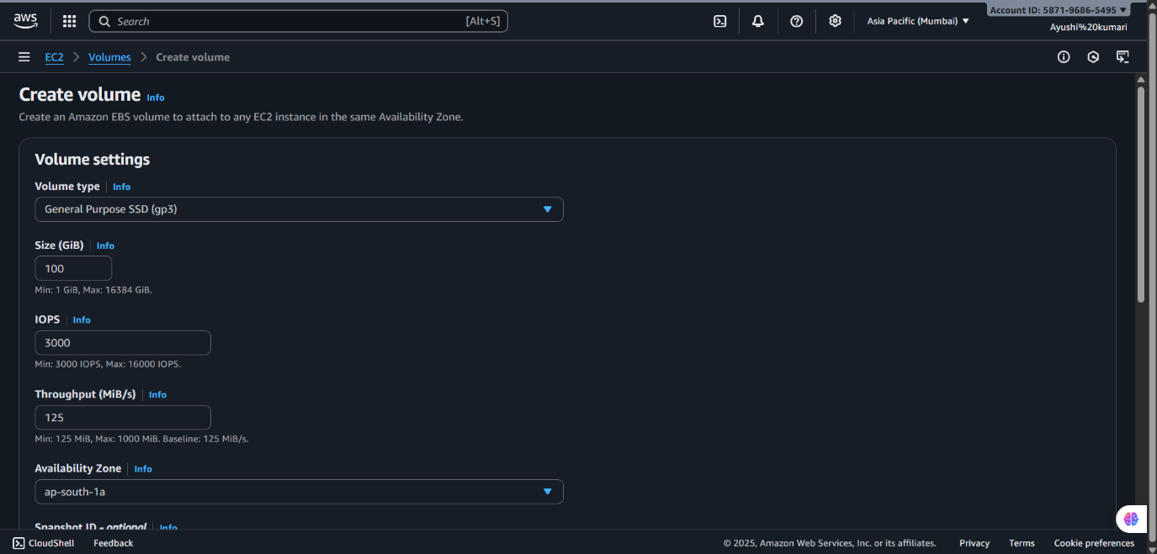
- Click "Next" or scroll down for more options:
- (Optional) Configure Snapshot, enable Encryption, and add Tags.
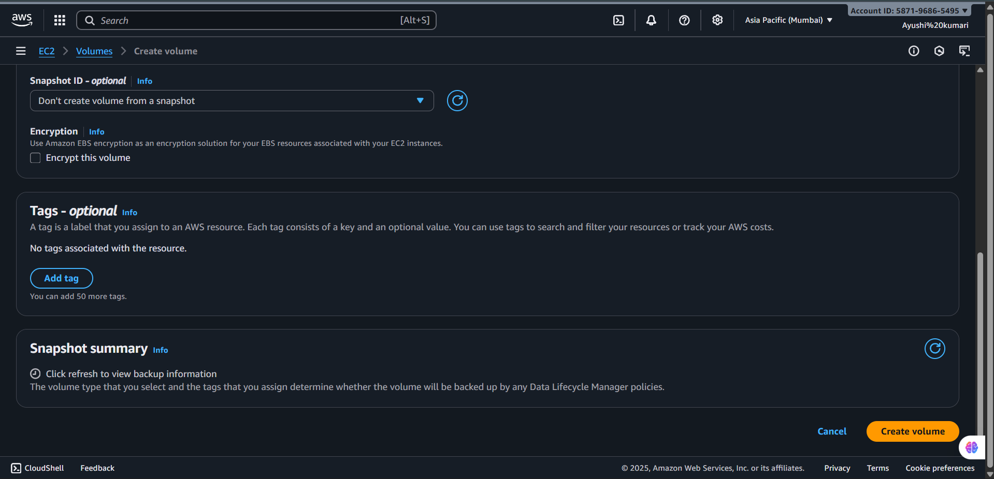
- Review settings and click "Create volume"

- Verify EBS Volume Creation In "Volumes," confirm the new volume is listed and has desired configuration.
- Launch or Select an EC2 Instance In the "Instances" section of the EC2 dashboard, launch a new instance or select an existing one that matches the volume's availability zone.
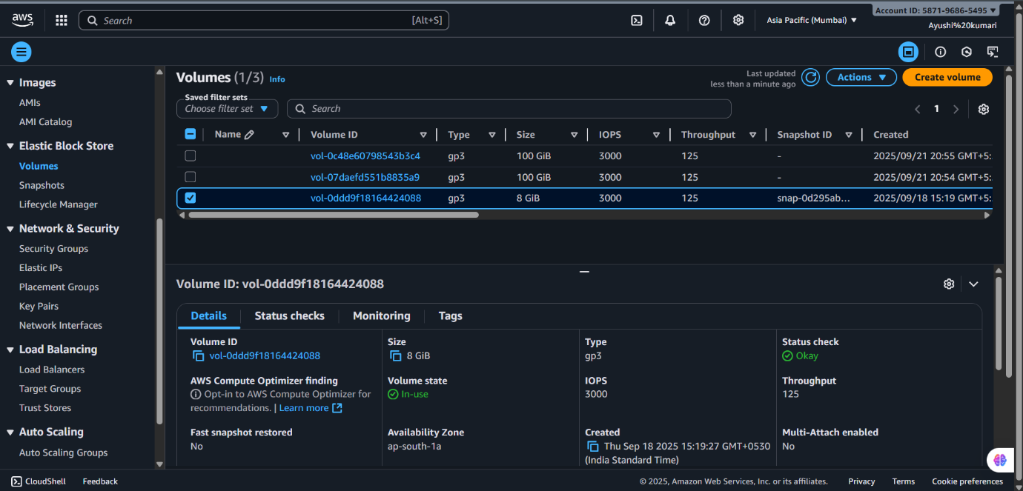
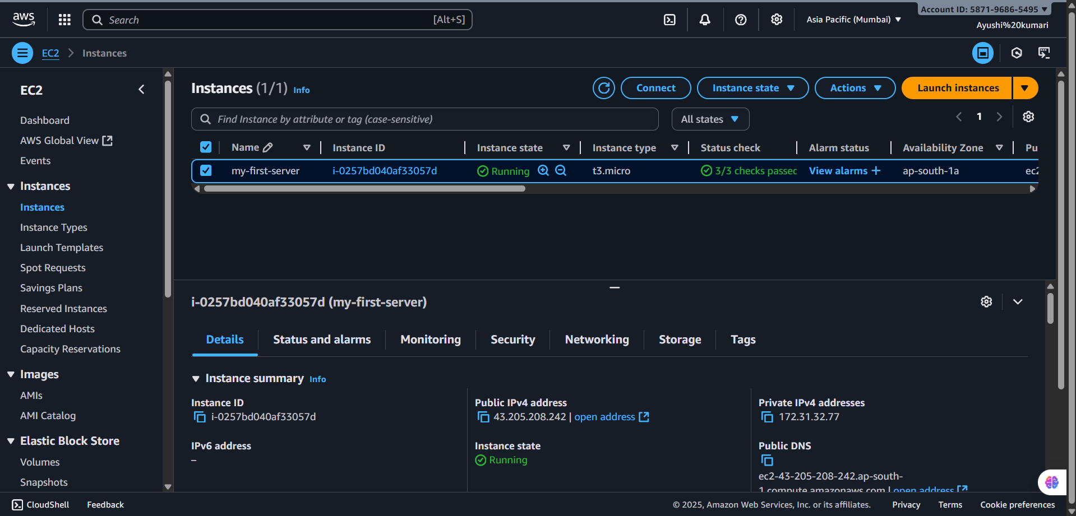
- Launch or Select an EC2 Instance In the "Instances" section of the EC2 dashboard, launch a new instance or select an existing one that matches the volume's availability zone.

- Attach EBS Volume to Instance In the Volumes list, select the new volume.
- Choose "Actions" > "Attach volume."
- Select the compatible EC2 instance and confirm .Ensure a green banner indicates successful attachment, and the volume status changes to "In-use".
- Connect to the EC2 Instance In "Instances," select your instance and click "Connect."
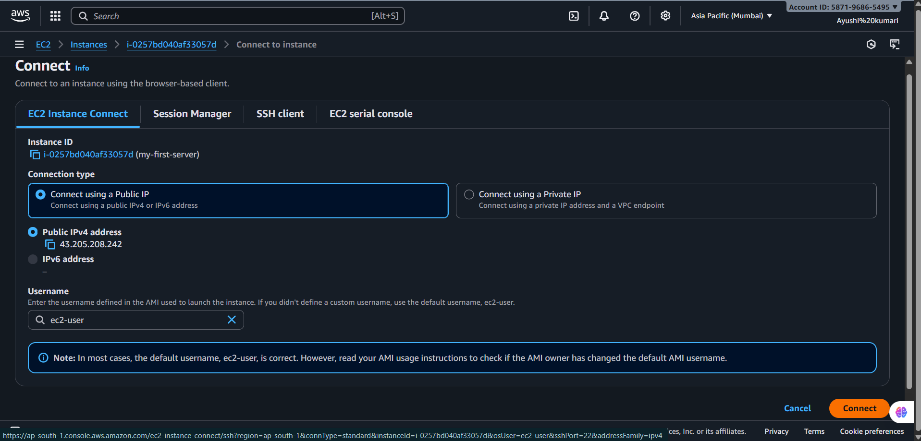
- Choose "EC2 Instance Connect" (browser-based SSH).
- Ensure the public IP and default username ("ec2-user") are selected.
- Click "Connect" to access the instance shell.
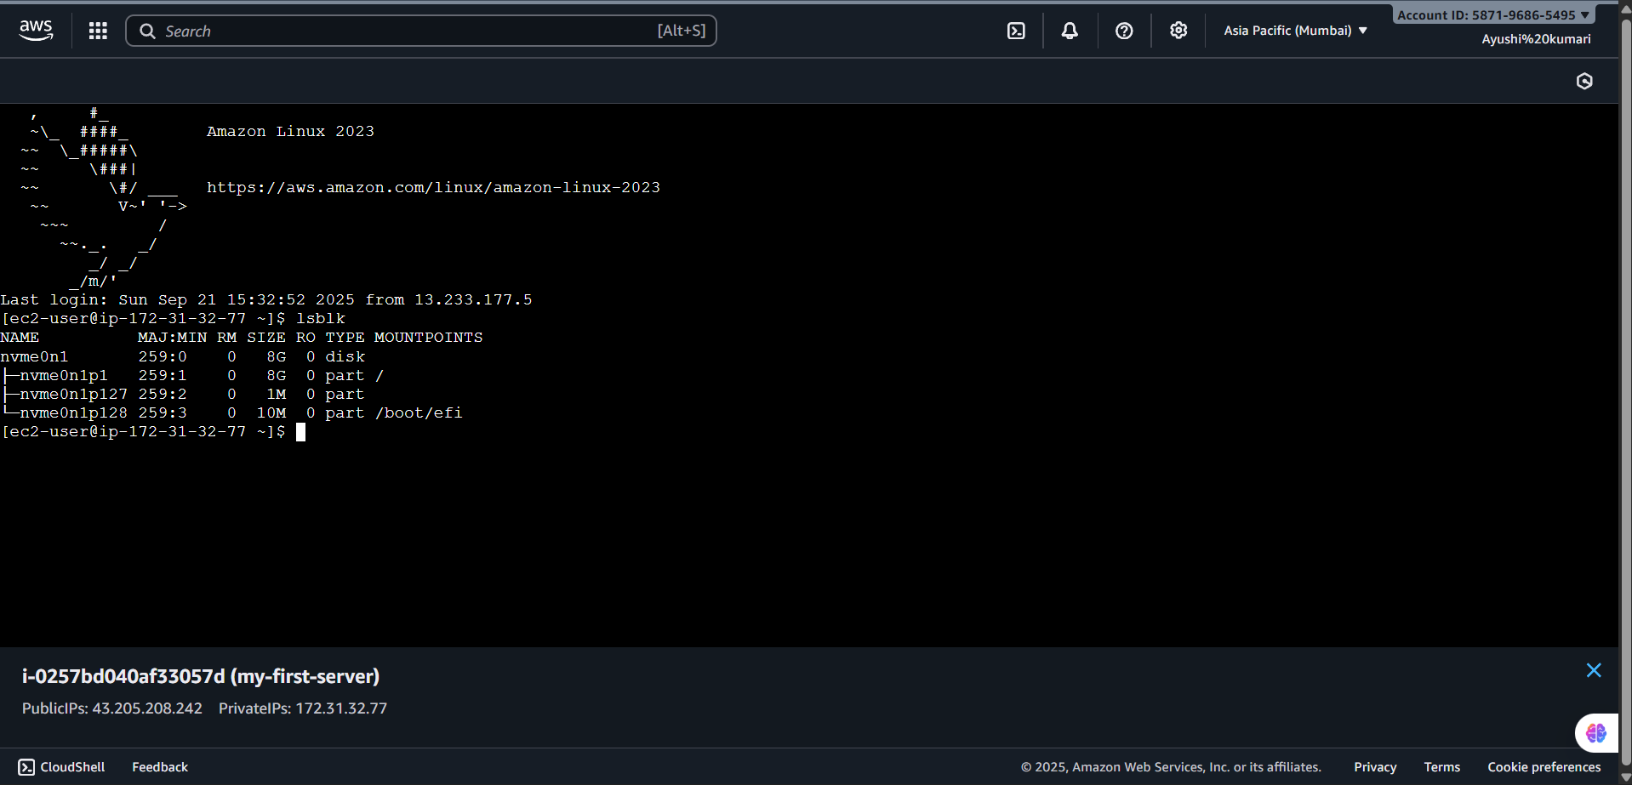
- Verify Disk Attachment in the Instance In the terminal, run “lsblk” to list all attached block devices.

- Ensure the new volume is visible in the output and available for mounting, formatting, or use.
